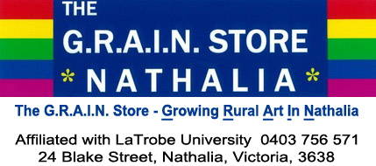
Please return this completed Expressions of Interest form
along with your artist statement biography, CV and images to:
watcharts@icloud.com

Further details contact Ken Wong 0419 570 846
________________________________________________________________________
EXPRESSIONS OF INTEREST – APPLICATIONS CLOSE 9/12/2016
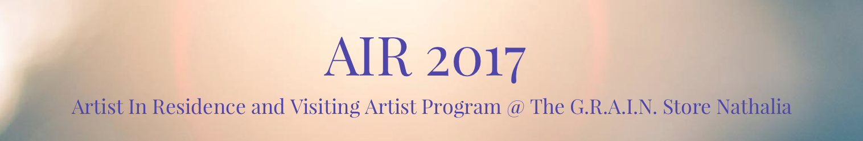

Name
Address
Email
Phone

I would like to express my interest in AIR 2017 for (you can select both)

Artist in Residence program Yes / No
Visiting artist program Yes / No

Artist Discipline
(eg, Visual Artist – printmaker, filmmaker, writer, etc)

You must supply an Artist Statement describing your current practice, current Biography & CV (max 2 x A4 pages combined). NB Please ensure you include any qualifications or experience as a teacher, lecturer or public speaker and/or workshop leader.

Images: Please attach a PDF (max 5 MB) of up to 10 pages with examples or images of your work or provide a webpage address where this or other media (including video) can be viewed or downloaded.

Preferences (optional) If you have a scheduling preference please complete below
Preferred Month

Preferred Start date
Preferred End Date

For this residency or artist visit I would prefer to travel:
Alone | Yes/No
With Non-Artist partner | Yes/No
With artist partner who would also be program participant (If this is the case please name your partner and include a second EOI for them) | Yes/No
With one or more artist collaborators who would be program participants (If this is the case please name collaborators and include a separate EOI for each of them) | Yes/No

Applicants must be 18 years of age or more.

